JSS Law College
Autonomous
Kuvempunagar, Mysuru

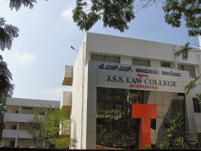

INTERNSHIP REPORT AND DIARY
2021

